

School of Computer Science Engineering and Information Systems
Fall Semester 2026-2027
Department of Software and Systems Engineering
SWE3004 - Software Design and Development Project
Review -1
Date: 12.8.2026

Agriculture Farm Digital Twin for Scenario Analysis
22MIS0576-N. Sakthivel

Under the Guidance of
Dr. Priya V
SCORE

Guide Signature with date

Internal Examiner -1 Internal Examiner-2
Signature Signature
ABSTRACT:
Farmers, especially small and marginal ones, face constant uncertainty while planning their crops. Unpredictable weather, pest attacks, and sudden changes in market prices often lead to wrong decisions, resulting in yield loss and financial stress. Some digital twin systems have been developed to help farmers by creating a virtual model of the farm, but most of them depend on expensive sensors and IoT devices installed in the field. This makes them unaffordable for small farmers and difficult to scale across large or scattered land holdings.
This project proposes a software-based agriculture digital twin that does not use any physical sensors. Instead, it uses freely available public data such as weather forecasts, soil information, satellite images, historical yield records, and market prices to build a virtual model of the farm. This model is regularly updated and is used to run "what-if" simulations — for example, comparing outcomes if a farmer chooses a different crop, irrigation schedule, or planting time — before actually implementing it in the field. A machine learning model predicts the expected yield along with how confident the prediction is, and a chatbot explains the results to the farmer in simple language, based on the actual reasons behind the prediction rather than generic responses. This approach removes hardware cost and makes data-driven farm planning accessible to smallholder farmers.

INTRODUCTION:
Agriculture is still the main source of income for a large section of people in India, and most of these farmers are smallholders with limited land and limited money to invest. Every season, farmers have to make important decisions — which crop to grow, when to plant it, how much water to give, and when to sell the produce. These decisions are usually based on personal experience, advice from other farmers, or guesswork, rather than any proper data or planning tool.
This lack of planning becomes a problem because farming outcomes depend heavily on things the farmer cannot control — weather changes, pest outbreaks, and market price fluctuations. A wrong decision, like planting a crop just before an unexpected dry spell, or growing a crop whose price crashes by harvest time, can cause heavy losses. In recent years, "digital twin" technology has been used in agriculture to reduce this uncertainty. A digital twin is basically a virtual copy of a real farm, built using data, that can be used to monitor conditions and even predict outcomes before they happen in real life.
However, most of the existing agricultural digital twins depend on physical sensors placed in the field — soil moisture sensors, IoT nodes, weather stations, etc. While these sensors give accurate real-time data, they are expensive to buy, install, and maintain. For a small farmer or a farming cooperative with limited budget, this is simply not practical. This creates a gap — the farmers who need this kind of decision support the most are the ones who can least afford the current sensor-based solutions.
This project tries to close that gap by building a digital twin that works without any physical sensors, using only data that is already publicly available for free, such as satellite images, government weather data, and historical records.

PROBLEM STATEMENT:
Smallholder farmers and agricultural cooperatives lack access to affordable, data-driven tools that help them plan crop, irrigation, and resource decisions in advance. Existing agricultural digital twin systems that provide this kind of decision support rely on costly sensor and IoT infrastructure, making them financially out of reach for most small farms and difficult to scale across fragmented or widely distributed land holdings. As a result, farmers continue to rely on guesswork and past experience, leading to inefficient resource use, avoidable yield losses, and reduced income, especially under changing weather and market conditions.

OBJECTIVES:
- To design a software-only digital twin of a farm using publicly available data sources (weather forecasts, soil maps, satellite vegetation indices, historical yield data, and market prices) instead of physical sensors.
- To build a machine learning-based forecasting model that predicts crop yield along with a confidence range, rather than a single fixed number.
- To develop a scenario simulation module that allows farmers to compare outcomes of different choices (crop selection, irrigation schedule, planting time) before implementing them in the real field.
- To build a chatbot using retrieval-augmented generation (RAG) that explains the model's predictions and recommendations to farmers in simple, understandable language, grounded in the actual factors influencing the prediction.
- To make the entire system deployable at low cost, so that it can be used by smallholder farmers and cooperatives without needing any hardware investment.

SCOPE OF THE PROJECT:
This project covers the design and development of a farm-level digital twin system that uses only public datasets — it does not involve installing or working with any physical sensors, IoT devices, or drones. The system will focus on a defined set of crops and a specific region for testing and validation, rather than covering every crop and every geography. It includes yield forecasting, scenario-based simulation for crop, irrigation, and planting decisions, and a chatbot-based advisory interface accessible through a dashboard.
The project does not cover real-time field monitoring (since there are no sensors feeding live ground data), automated farm machinery control, or direct financial transactions such as crop insurance or loan processing. The focus is strictly on decision support — helping farmers plan better — not on automating or executing farm operations.

PROPOSED SYSTEM:
The proposed system is a software-based agriculture digital twin system that creates an updated virtual representation of a farm using publicly available agricultural and environmental data, without requiring physical sensors or IoT devices. The user provides the farm location, crop, and season, after which the system collects relevant weather forecasts, soil information, satellite vegetation data, historical yield records, and market prices for the selected farm and stores them for further processing.
The collected information is used to maintain a farm-specific digital shadow containing soil conditions, weather trends, vegetation health, and previous crop performance. Machine learning models such as LSTM/Transformer are then used to estimate crop yield and market price trends along with their confidence ranges. The system also provides a scenario simulation feature that allows farmers to change factors such as crop type, planting date, and irrigation schedule and compare the possible outcomes. SHAP-based explanations are used to identify the important factors behind the predictions, while an RAG-based chatbot uses these results to provide simple and understandable advice. The complete system is provided through a web dashboard where farmers and cooperatives can manage their farms, view forecasts, compare scenarios, and interact with the advisory chatbot.
LITERATURE SURVEY
S.No | Title & Citation | Merits | Demerits
1 | Haji Seyed Asadollah, S. B., Jodar-Abellan, A., & Pardo, M. Á. (2024). Optimizing machine learning for agricultural productivity: A novel approach with RScv and remote sensing data over Europe. Agricultural Systems, 218, 103955. | Uses a new tuning method (RScv) to make ML models like AdaBoost and Random Forest predict crop yield better. Tested on four crops across 20 European countries over 20 years, with accuracy around 0.90 for the best model. Also checks how confident the model is in its predictions. | Only focuses on predicting yield, not building a full farm-level twin. Doesn't include farmer decisions, market prices, or management data. Authors themselves say more variables and wider testing are needed.
2 | Kamangir, H., Sams, B. S., Dokoozlian, N., Sanchez, L., & Earles, J. M. (2024). Large-scale spatio-temporal yield estimation via deep learning using satellite and management data fusion in vineyards. Computers and Electronics in Agriculture, 216, 108439. | Combines satellite images with farm management details (like row spacing) to predict grape yield early in the season. Tested on almost 5 million grapevines over 4 years, giving solid accuracy (R² = 0.76). | Built only for vineyards, so it won't directly work for other crops like rice or cotton. Needs detailed management data that small farmers may not have. Only predicts yield, doesn't simulate different farming choices.
3 | Mitsanis, C., Hurst, W., & Tekinerdogan, B. (2024). A 3D functional plant modelling framework for agricultural digital twins. Computers and Electronics in Agriculture, 218, 108733. | Proposes a way to add realistic 3D plant models into digital twins, so the twin can simulate things like plant growth, disease spread, and pruning. | Mostly a theoretical framework, not a working farmer-facing system. Building 3D plant models needs heavy computing power. Doesn't cover market prices or decision support for farmers.
4 | Cohen, Y., Malka, A., Goldwasser, Y., Scudiero, E., Goldshtein, E., Keisar, O., Lidor, G., & Ravid, G. (2025). Leveraging satellite imagery and yield records to assess in-season maize field functionality with machine learning classification. Computers and Electronics in Agriculture, 238, 110809. | Uses satellite images and past yield data to check how well a maize field is performing during the season, not just at harvest. Combining different types of features improved accuracy noticeably. Even built a web-based tool for this. | Only works for maize fields and needs historical yield records, which not every farmer has. It classifies field performance, but doesn't predict final yield or simulate future decisions.
5 | Onoufriou, G., Hanheide, M., & Leontidis, G. (2023). Premonition Net, a multi-timeline transformer network architecture towards strawberry tabletop yield forecasting. Computers and Electronics in Agriculture, 208, 107784. | Uses a transformer model that looks at past, present, and expected future data together to predict strawberry yield 3 weeks ahead, with good accuracy. Useful for planning labor and sales in advance. | Built only for strawberries grown on tabletops, needing very specific and detailed data. The authors themselves say getting enough good data is still a big problem. Not a general farm decision-support tool.
6 | Cesco, S., Sambo, P., Borin, M., Basso, B., Orzes, G., & Mazzetto, F. (2023). Smart agriculture and digital twins: Applications and challenges in a vision of sustainability. European Journal of Agronomy, 146, 126809. | Suggests designing farm systems around what decisions farmers actually need to make, not just collecting data for its own sake. Shows this idea with a real example on nitrogen fertilizer use. Talks about the special challenges small farms face. | Mainly a concept paper and case study, not a full working software system. Talks about many technologies that can be costly to set up. Doesn't give a ready-to-use forecasting or simulation tool.
7 | Paudel, D., de Wit, A., Boogaard, H., Marcos, D., Osinga, S., & Athanasiadis, I. N. (2023). Interpretability of deep learning models for crop yield forecasting. Computers and Electronics in Agriculture, 206, 107663. | Shows that deep learning models like LSTM can be made understandable by checking which features influence the prediction, and gets experts to verify if this matches real farming knowledge. Proves that accuracy and explainability can go together. | The explanations are added after the model makes its prediction, so they don't always capture how features interact with each other. Needs a lot of training data. The explanation method itself is only an approximation.
8 | Leukel, J., Zimpel, T., & Stumpe, C. (2023). Machine learning technology for early prediction of grain yield at the field scale: A systematic review. Computers and Electronics in Agriculture, 207, 107721. | Reviews 46 different studies on early yield prediction, showing what data and methods are commonly used, and how far in advance predictions can be made. Useful as a broad reference. | The studies reviewed are very different from each other in datasets and methods, making it hard to directly compare. Many studies didn't properly report their data sizes or use good feature selection.
9 | Tripathi, A., Kaushal, I., Revolti, A., Benedetti, L., & Dallasega, P. (2025). Digital twin driven quality control in smart mobile factories: A framework in precast manufacturing. Procedia CIRP, 134, 801–806. | Shows how a digital twin can combine sensor data and manual inspection data to catch quality problems early and create feedback loops for better decisions — an idea borrowed here from outside agriculture. | Built for precast concrete manufacturing, not farming. Relies heavily on sensors and industrial-scale computing, which wouldn't directly work for smallholder farms without major changes.
10 | Purcell, W., & Neubauer, T. (2023). Digital twins in agriculture: A state-of-the-art review. Smart Agricultural Technology, 3, 100094. | Reviews existing agricultural digital twins and clearly separates the levels of "twin-ness" — Digital Model, Digital Shadow, and full Digital Twin — helping define what a system should be called. Points out that true digital twins need two-way, real-time data flow. | It's a review paper, not a working system. It notes that most existing digital twins are still just pilot projects, mostly in greenhouses or aquaponics, and that "what-if" simulation is still rare in practice.
11 | Singh, N., Wang'ombe, J., Okanga, N., Zelenska, T., Repishti, J., G K, J., Mishra, S., Manokaran, R., Singh, V., Rafiq, M. I., Gandhi, R., & Nambi, A. (2024). Farmer.Chat: Scaling AI-powered agricultural services for smallholder farmers. arXiv preprint, arXiv:2409.08916. | A generative AI chatbot deployed in 4 countries, used by over 15,000 farmers, answering more than 300,000 questions. Supports multiple languages and even images/audio, which helps low-literacy farmers. Uses RAG so answers are grounded in real agricultural documents. | Depends on having a large, well-curated knowledge base to stay accurate — hard to maintain and localize everywhere. The paper notes concerns about bias, data privacy, and farmers becoming too dependent on the tool. It's a general advisory chatbot, not linked to a farm-specific forecasting/simulation model.
12 | Manogna, R. L., Dharmaji, V., & Sarang, S. (2025). Enhancing agricultural commodity price forecasting with deep learning. Scientific Reports, 15(1), 20903. | Compares many models (LSTM, GRU, ARIMA, etc.) to forecast prices of 23 different crops using 14 years of Indian market data. Shows LSTM and GRU clearly beat older statistical methods, which is useful for farmers deciding when/what to sell. | Focuses only on price forecasting, with no link to weather, soil, or yield data. Doesn't help farmers decide what to plant — only what prices might look like. Suggests future work should combine price data with other factors like weather.
13 | Petropoulos, T., Benos, L., Berruto, R., Miserendino, G., Marinoudi, V., Busato, P., Zisis, C., & Bochtis, D. (2025). Interpretable machine learning for legume yield prediction using satellite remote sensing data. Applied Sciences, 15(13), 7074. | Combines satellite images with SHAP explainability to predict lupin (a legume) yield and clearly show which factors drove each prediction — directly relevant to building trustworthy, explainable advisory tools. | Focused on one under-studied crop (lupin) in one region of Italy, so results may not transfer elsewhere. Doesn't include a scenario simulation or advisory chatbot layer — stops at prediction and explanation.
14 | Jácome Galarza, L., Realpe, M., Viñán-Ludeña, M. S., Calderón, M. F., & Jaramillo, S. (2025). AgriTransformer: A transformer-based model with attention mechanisms for enhanced multimodal crop yield prediction. Electronics, 14(12), 2466. | Uses a transformer model with attention to combine multiple types of data (like satellite and weather) for more accurate yield prediction — directly relevant to the LSTM/transformer approach planned for this project. | Focused purely on prediction accuracy, without any decision-support, scenario simulation, or farmer-facing explanation layer. Multimodal transformer models can be computationally heavy to deploy at low cost.
15 | Lal, B., Shukla, A., Agrawal, A. K., Ramasamy, R. K., & Dubey, P. (2026). Attention-based transformer framework with predictive uncertainty quantification for multi-crop yield forecasting. Computation, 14(4), 93. | Directly relevant to this project's "calibrated confidence" goal — combines a transformer model with three different ways (Monte Carlo Dropout, Quantile Regression, Bayesian Attention) of estimating how confident the model is, not just a single yield number. | Tested only on coarse tabular climate/soil data, not high-resolution satellite imagery. The authors note it's an integration of existing uncertainty techniques rather than a completely new method. Still just a forecasting model, with no scenario simulation or advisory layer.

FINDINGS IN LITERATURE SURVEY:
- Most existing studies focus mainly on crop yield prediction and do not provide complete decision support for farmers.
- Many agricultural Digital Twin systems depend on IoT sensors, which can be costly for small and marginal farmers.
- Explainability and prediction confidence are not commonly provided together, making it difficult to understand how reliable a prediction is.
- Yield prediction and market price prediction are usually handled separately, instead of considering both when selecting a crop.
- Most systems do not provide what-if analysis, such as checking the effect of low rainfall, high temperature, or price changes.
- The main research gap is the lack of a single sensor-free system that combines Digital Twin, ML prediction, confidence, explainability, scenario testing, market information, and farm-specific recommendations.

METHODOLOGY:
The project is carried out in six main stages, moving from raw public data all the way to farmer-facing recommendations.
Stage 1: Requirement and Decision Mapping
Before touching any data, the specific decisions a farmer needs help with are listed out first — for example, which crop to plant, when to plant it, how much to irrigate, and whether current market conditions favor selling now or later. This "decision-first" approach (instead of just collecting data and hoping it's useful) ensures the system is built around real farmer needs, following the infological design approach discussed in the literature survey (Cesco et al., 2023).
Stage 2: Data Collection
Public datasets are identified and collected for the target region and crops, including:
- Weather data (rainfall, temperature, forecasts) from NOAA
- Soil data from government/public soil maps
- Satellite vegetation indices (e.g., NDVI) from NASA MODIS and Sentinel
- Historical yield records from agricultural databases
- Market price data from sources like AGMARKNET
This data is pulled through APIs or bulk downloads and stored in a structured format for further processing.
Stage 3: Data Preprocessing and Farm Model Construction
The raw data is cleaned (handling missing values, aligning different time formats, removing outliers) and organized into a spatial database using PostGIS, so that data can be tied to a specific farm's exact location. This forms the "digital shadow" — a regularly updated virtual representation of the farm's current conditions.
Stage 4: Model Development
(a) Yield Forecasting Model: An LSTM/transformer-based deep learning model is trained on the historical yield, weather, soil, and satellite data to predict crop yield. Instead of giving just one number, the model is designed to output a confidence range (using techniques like Monte Carlo Dropout or Quantile Regression), so the farmer knows how reliable the prediction is.
(b) Price Forecasting Model: A separate time-series model (LSTM/GRU) is trained on historical market price data to forecast expected price trends for the farmer's crops.
(c) Scenario Simulation Engine: This module takes the trained models and lets the user change input conditions (crop choice, irrigation schedule, planting date) to simulate different possible outcomes side by side, before any real-world action is taken.
(d) Explainability Layer: SHAP (or a similar feature attribution method) is applied to the forecasting models so that each prediction can be traced back to the specific factors that influenced it (e.g., "low rainfall" or "falling prices"), rather than treating the model as a black box.
Stage 5: Advisory Chatbot Development
A retrieval-augmented generation (RAG) chatbot is built to take the outputs of the forecasting and simulation models (along with their SHAP-based explanations) and turn them into simple, farmer-friendly language. The chatbot retrieves relevant explanations and context before generating its response, so its advice stays grounded in the actual model output instead of making things up.
Stage 6: Dashboard Development and Integration
A web-based dashboard is built using React (frontend) and Django/Flask (backend), where the farmer can view yield/price forecasts, run different what-if scenarios, and chat with the advisory bot — all in one place. The complete system is tested with real regional data to check accuracy, usability, and response quality before final evaluation.

SOFTWARE REQUIREMENTS:
Functional Requirements
- User Authentication: User registration, login, logout, and role-based access for farmers and cooperatives.
- Farm Profile Management: Create and manage farm profiles using location, crop, season, and farm details.
- Data Collection: Automatically collect weather, satellite, soil, historical yield, and market price data from public sources.
- Yield and Price Prediction: Predict crop yield and market price trends with confidence ranges.
- Scenario Simulation: Allow users to change crop, planting date, and irrigation conditions and simulate different outcomes.
- Explainability and Chatbot: Provide SHAP-based prediction explanations and a simple chatbot for farming-related questions.
- Dashboard: Display farm information, forecasts, scenario comparisons, and recommendations through a web dashboard.
Non-Functional Requirements:
- Performance: Provide predictions, simulations, and dashboard results within a few seconds.
- Security: Protect user accounts, farm information, and access to the system from unauthorized users.
- Reliability: Handle missing or delayed data and clearly communicate prediction uncertainty.
- Scalability: Support increasing numbers of farmers, farms, crops, and regions without major redesign.
- Usability: Provide a simple, responsive, and easy-to-understand interface for farmers.
- Maintainability: Keep data collection, prediction, simulation, chatbot, and dashboard components modular and easy to update.
- Cost Efficiency: Use free/public data sources and standard cloud infrastructure to minimize system and deployment costs.

SYSTEM ARCHITECTURE: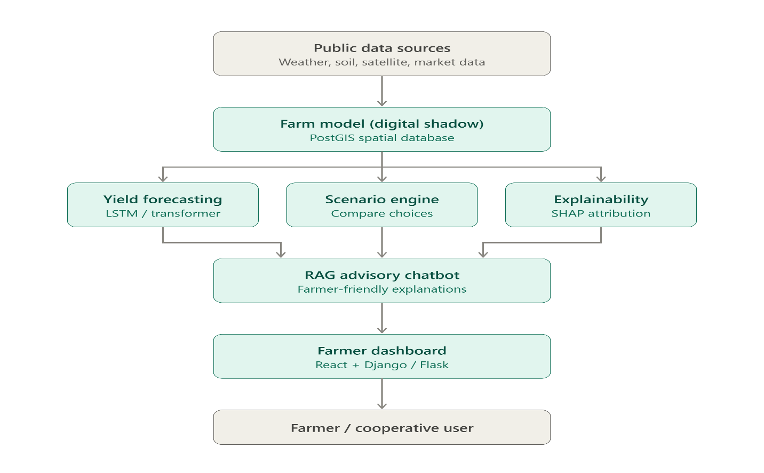
[10]. UML DIAGRAMS:
Use Case Diagram:
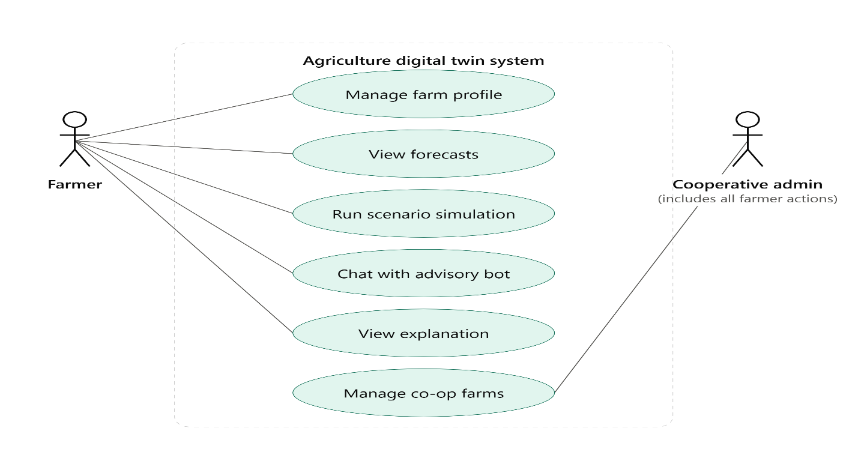
Class Diagram:
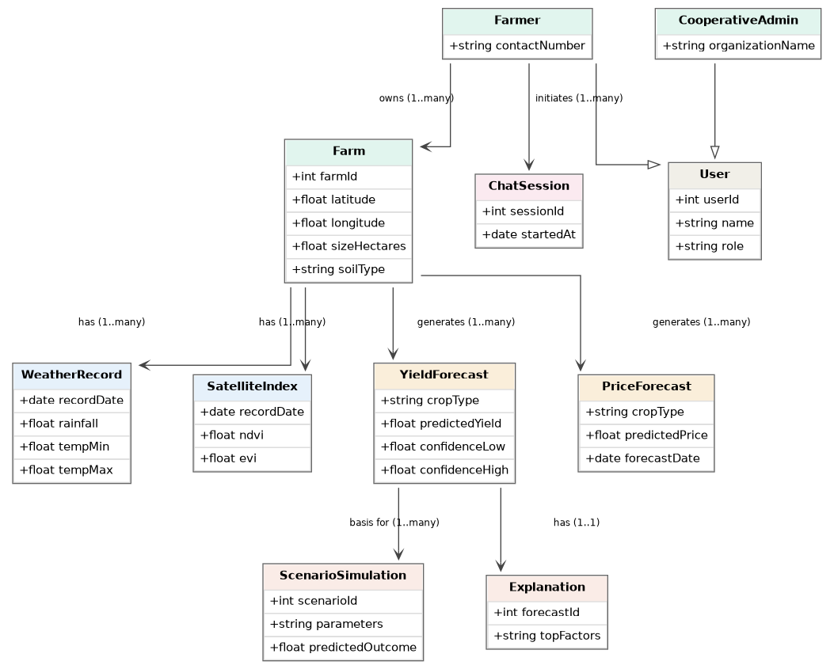
SUMMARY:
This project sets out to solve a real, practical problem — smallholder farmers and cooperatives making crop, irrigation, and selling decisions based on guesswork rather than data, simply because the data-driven tools that exist today (agricultural digital twins) depend on expensive sensors and IoT hardware they cannot afford.
The proposed solution is a software-only agriculture digital twin that replaces physical sensors with free, publicly available data — weather forecasts, soil maps, satellite vegetation indices, historical yield records, and market prices. This data is used to build and continuously update a virtual model of the farm, technically framed as a "calibrated digital shadow" rather than a full real-time digital twin, since it does not receive live sensor feedback from the field.
On top of this farm model, the system runs three connected functions: a machine learning model forecasts crop yield along with a confidence range instead of a single guess; a scenario simulation engine lets the farmer compare different choices (crop, irrigation, planting date) before committing to them in real life; and an explainability layer (SHAP-based) makes sure every prediction can be traced back to the actual factors that caused it. All of this is delivered to the farmer through a simple web dashboard and a RAG-based chatbot that explains results in plain language, grounded in the model's real reasoning rather than generic AI responses.

REFERENCES:
- Haji Seyed Asadollah, S. B., Jodar-Abellan, A., & Pardo, M. Á. (2024). Optimizing machine learning for agricultural productivity: A novel approach with RScv and remote sensing data over Europe. Agricultural Systems, 218, 103955.
- Kamangir, H., Sams, B. S., Dokoozlian, N., Sanchez, L., & Earles, J. M. (2024). Large-scale spatio-temporal yield estimation via deep learning using satellite and management data fusion in vineyards. Computers and Electronics in Agriculture, 216, 108439.
- Mitsanis, C., Hurst, W., & Tekinerdogan, B. (2024). A 3D functional plant modelling framework for agricultural digital twins. Computers and Electronics in Agriculture, 218, 108733.
- Cohen, Y., Malka, A., Goldwasser, Y., Scudiero, E., Goldshtein, E., Keisar, O., Lidor, G., & Ravid, G. (2025). Leveraging satellite imagery and yield records to assess in-season maize field functionality with machine learning classification. Computers and Electronics in Agriculture, 238, 110809.
- Onoufriou, G., Hanheide, M., & Leontidis, G. (2023). Premonition Net, a multi-timeline transformer network architecture towards strawberry tabletop yield forecasting. Computers and Electronics in Agriculture, 208, 107784.
- Cesco, S., Sambo, P., Borin, M., Basso, B., Orzes, G., & Mazzetto, F. (2023). Smart agriculture and digital twins: Applications and challenges in a vision of sustainability. European Journal of Agronomy, 146, 126809.
- Paudel, D., de Wit, A., Boogaard, H., Marcos, D., Osinga, S., & Athanasiadis, I. N. (2023). Interpretability of deep learning models for crop yield forecasting. Computers and Electronics in Agriculture, 206, 107663.
- Leukel, J., Zimpel, T., & Stumpe, C. (2023). Machine learning technology for early prediction of grain yield at the field scale: A systematic review. Computers and Electronics in Agriculture, 207, 107721.
- Tripathi, A., Kaushal, I., Revolti, A., Benedetti, L., & Dallasega, P. (2025). Digital twin driven quality control in smart mobile factories: A framework in precast manufacturing. Procedia CIRP, 134, 801–806.
- Purcell, W., & Neubauer, T. (2023). Digital twins in agriculture: A state-of-the-art review. Smart Agricultural Technology, 3, 100094.
- Singh, N., Wang'ombe, J., Okanga, N., Zelenska, T., Repishti, J., G K, J., Mishra, S., Manokaran, R., Singh, V., Rafiq, M. I., Gandhi, R., & Nambi, A. (2024). Farmer.Chat: Scaling AI-powered agricultural services for smallholder farmers. arXiv preprint.
- Manogna, R. L., Dharmaji, V., & Sarang, S. (2025). Enhancing agricultural commodity price forecasting with deep learning. Scientific Reports, 15(1), 20903.
- Petropoulos, T., Benos, L., Berruto, R., Miserendino, G., Marinoudi, V., Busato, P., Zisis, C., & Bochtis, D. (2025). Interpretable machine learning for legume yield prediction using satellite remote sensing data. Applied Sciences, 15(13), 7074.
- Jácome Galarza, L., Realpe, M., Viñán-Ludeña, M. S., Calderón, M. F., & Jaramillo, S. (2025). AgriTransformer: A transformer-based model with attention mechanisms for enhanced multimodal crop yield prediction. Electronics, 14(12), 2466.
- Lal, B., Shukla, A., Agrawal, A. K., Ramasamy, R. K., & Dubey, P. (2026). Attention-based transformer framework with predictive uncertainty quantification for multi-crop yield forecasting. Computation, 14(4), 93.

